**Bug on Page ‘my.bonify.de’:**

**Issues 8:**

On '**https://my.bonify.de/login?next=/**' Page, ‘imprint’ should be ‘Imprint’ and ‘data protection’ should be ‘Data Protection’.

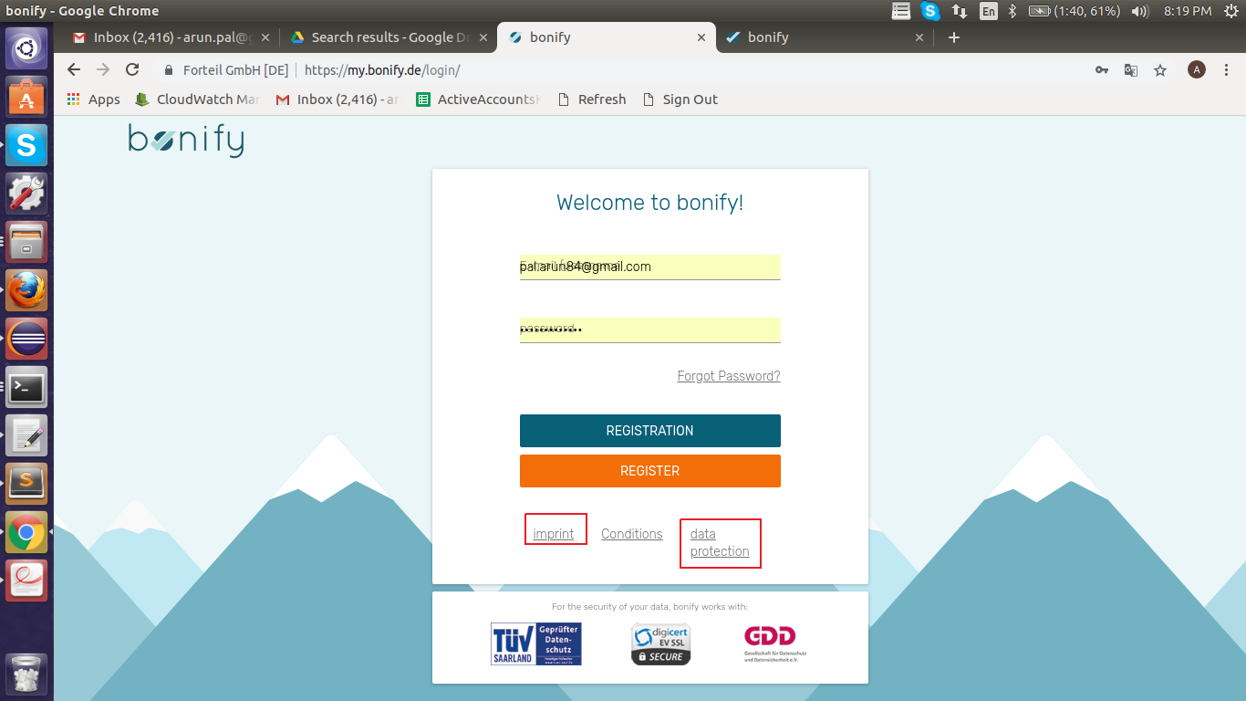

**Steps To Reproduce:**

1: Start Chrome Browser with url **‘**https://my.bonify.de/login?next=/**’.**

2: Observe ‘Imprint’ and ‘data protection’ link at bottom of the Page

**Expected Result:** Starting letter of ‘imprint’ and ‘data protection’ should be capital letter.

**Actual Result:** Starting letter of ‘imprint’ and ‘data protection’ are in small letter.

**Browser:** Chrome (Version 70)

**OS:** Ubuntu (16)

**Priority:** P5

**Assign To :** Developer.